Modifications to Activity Table and Activity Scheduling process

Any activity that belongs to Cycle should be listed in the Activities list under that Cycle.

To link related activities and Cycle, Activity table should be altered to include CYCLE ID.

According to proposed design, once new cycle is created

1. System generates activities in Activity Table that
2. Creates activity for each Business day in the Cycle and populate that date in Activity.Date field.
3. Set same Activity Name Id as Cycle Name
4. Set Cycle Id equal to Cycle Id to which they belong (Cycle.CycleId=Activity.CycleId)
5. Turn Boolean values to TRUE to match cycle definition: HR, Materials, Machinery, Services, and Dangerous. \*Cycle definition needs to be modified to include Dangerous flag.
6. User will have to extend the cycle in order to add additional activities of the same type beyond the cycle dates
7. To support of the behavior described in “e”, modification to ActivityName table is required: alter table to add Cycle Flag that if turned “on”, will require user to create a cycle to generate activities of this type. Otherwise (turned off) user will be able to create a standalone activity
8. All the activities will be created as Routine activities by default, and have Routine set to TRUE. User has the right to uncheck the box. If activity is set as a Routine, then default times for start times and end of activity and break are populated according to the System Profile. (see system Profile document)
9. If Routine is “On” then start and finish times are read only fields. They become editable once the check box is “off.”

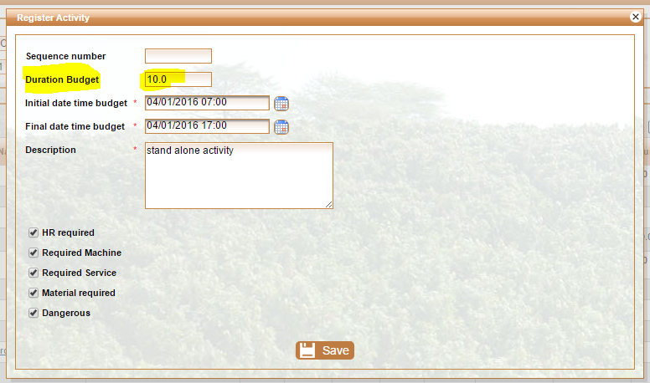

Routine

1. Move “Add Activity” functionality and rename it to “Add Standalone Activity” to Actvities Tab, under “Record Activities Budget” Menu item.
   1. User should be able to add stand-alone activity (not part of a cycle)
   2. To create a standalone activity, system should prompt user to select Activity Name from the list of names that have Cycle Flag off (FALSE).
   3. System should check that there is no so-named activity for the same day (validation on the Date and ActivtyNameId)
2. Under “Schedule Activities Budget” in the Crop Form, add Cycle filter

